**E-Channelling Website**



# Introduction

I Developed a Spring Boot Application called Medicare. Actually it's an E-Channelling website. The main service that users can get from this service is place an appointment to doctor and manage those appointments.

To do that I used 4 user categories in my application. And there are 8 servicers.

They are,

* **Visitors**: These are the un registered users.
* **Clients/Users**: These are registered users that can place an appointment.
* **Manager**: These users are belonging to their hospital. And their main responsibility is managing hospital channellings.
* **Admin**: This user can manage hospitals and can add managers to hospital and etc.

# Here are my servicers.

**Category**

This is the smallest service in my application. The main responsibility of this service is to manage Doctor’s categories. Like General, Dentist, Neurologist, etc.

**Doctor**



I used this service to manage Doctor’s and their categories (Which doctor have which categories).

**Hospital**

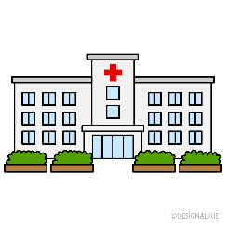

From this service I managed hospitals.

**Channelling**

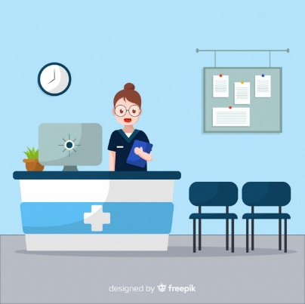

This is a one of main servicers in my application. I used this to manage channellings. Like which doctor available in which hospital.

**Appointment**

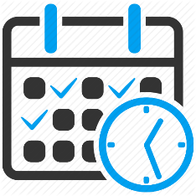

This is also a one of main service in my application, from this I managed user’s appointments.

**Client**



I used this service to manage all users of my application(Client’s/User’s/Managers/Admin)

**OAuth**



I managed all logins from this service. And I used password credentials flow.

**Discovery**



I used Eureka Discovery Service too.

# How I start?

1. **Backend Development**
   1. In this step I started to develop my micro-servicers. I started to develop them from simple servicers those are not tightly depend on other servicers. Like Category, Hospital, Doctor.
   2. I developed all CURD operations that I want and did validations.
   3. I tested developed servicers by using insomnia.
2. **Frontend Development**
   1. I developed frontend angular app for my backend servicers. I developed only components for my micro-servicers.
   2. And I did frontend validations too.
3. **Finalize**
   1. In between step 1st and 2nd I developed Oauth2 service and User service when they needed. Because its little bit hard to test with Oauth2.
   2. In this step I created user views like Home page, Profile page, Manager page, etc.
   3. I create Discovery Service and put my servicers to Dockers too,
   4. And I tested my application and fixed bugs.
   5. In step it’s so easy for me to create user views, test and bug fixing because I have already created components. So what I did is, place them in a correct place that I want. Testing and bug fixing is also easy this for me on this step because I already did most of them in 1st and 2nd steps.

# What I used for this application?

* Maven
* Spring boot
* MySql
* Spring Data JPA
* Spring Mail
* OAuth2
* Eureka Discovery Service
* Angular
* Docker